We would like to change the log in page a bit please.

The reasons for wanting to change the log in page is that lots of people are registering but not going all the way through to the profile page and icon etc.

So we want to make some changes to improve this.

**Changes for the “log in to your account” Page**

Can the “Forgot Password” be a bit more obvious and bolder please

Can the “Remember Password” be a bit more obvious & bolder please

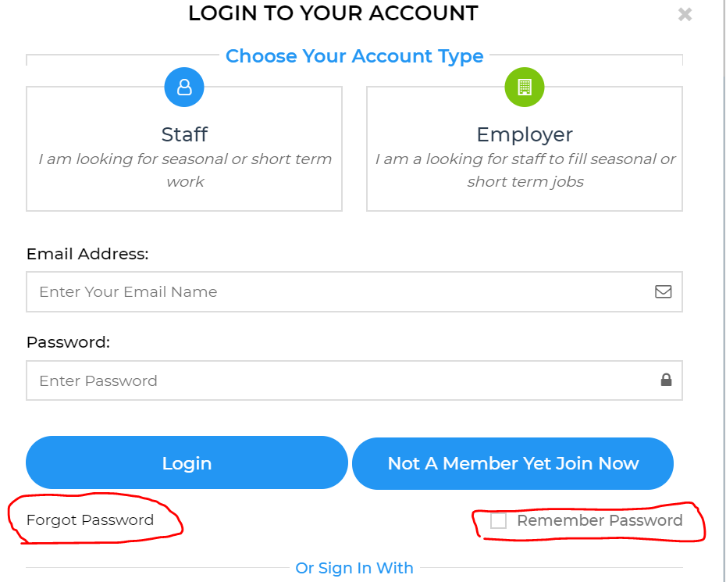

Can the wording be changed on the “Not a member Yet Join Now”

To “ Not A Member Yet?...Join Now.”

**Changes for the “Sign up to your account” page**

Please can you change the wording & font from “SIGNUP TO YOUR ACCOUNT”

To “Join Now” (do not use capitals)

Can you make the “Please choose your type of Membership”

To “Select Membership Type”

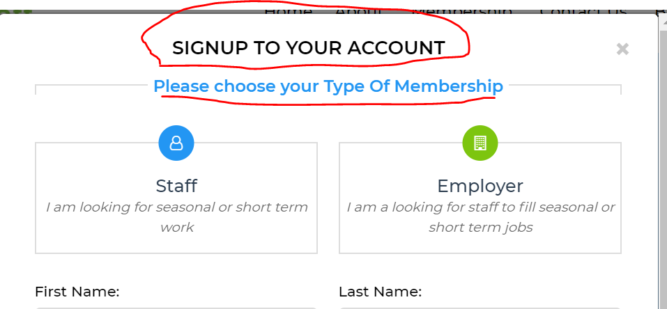

Can you please cut the size of the username box down to the same size as the other boxes

Can you add “Select your Street address” on the other side.

This would be the same as the google drop down menu used in the “Current location” field on the “your profile “section (see below)

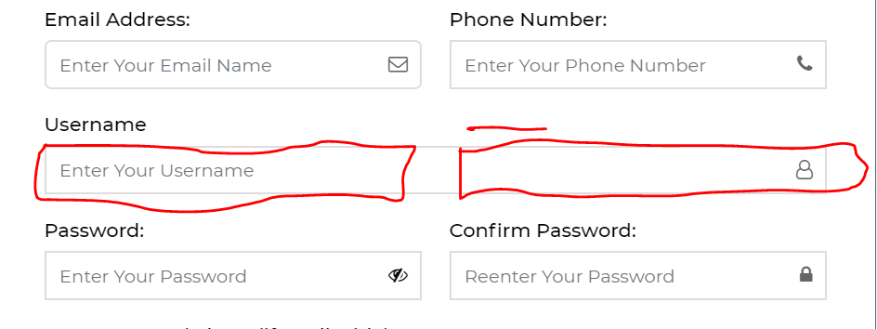

This would then pre populate (for the first time) the “Select your street Address” in the “current location” section of the “Your Profile” when people joined up. (and once they were verified they would then show on the map)

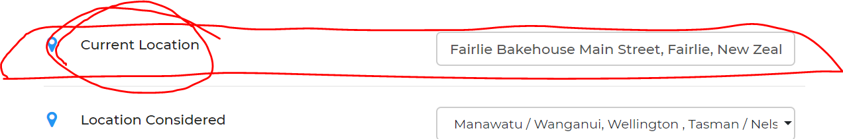

Can you please change the wording of the “ Sign up “ button to “Join Now” to make it consistent with all the other wording we are using.

Remove the “have a already account? Sign in Now”

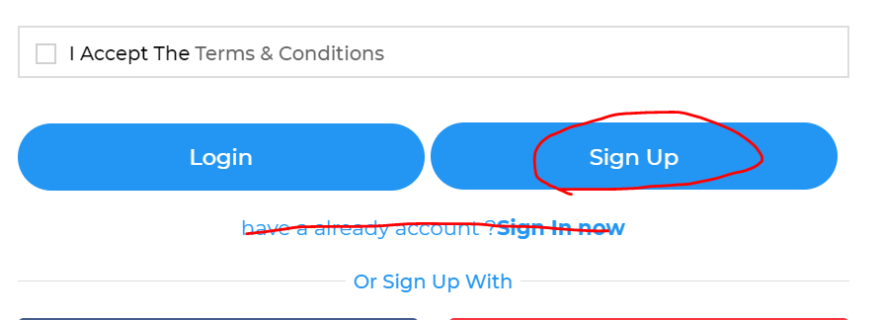

Can the “I accept the Terms & conditions” boxes be reduce to the same size as the others.

Can the “I am over 18” box be move to the same line as the “I accept the terms & Conditions” box

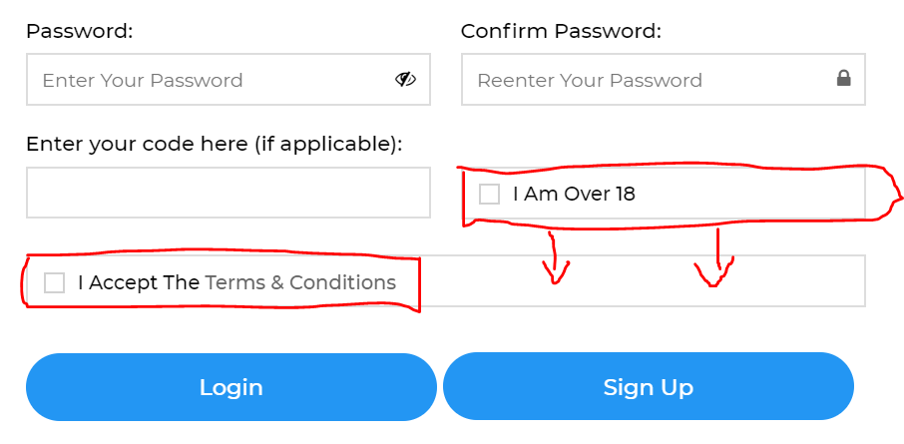

Where the “I am over 18” box **was** can we put in another box called “Date available to work from” This would be a calendar. ( and would prepopulated the “Dates available to work from” box in the “Your profile” section.

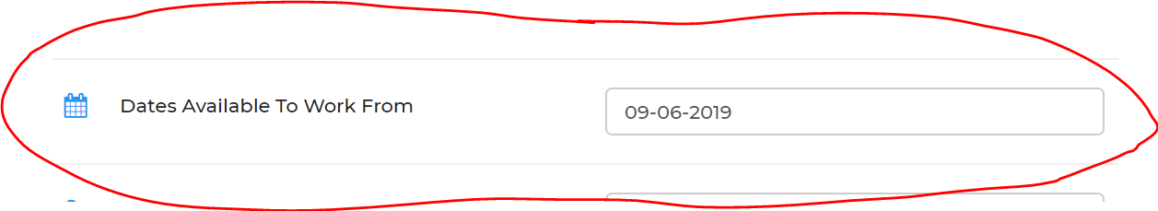

Once they hit the “Sign up “ button.

This screen appears. (this is where many of them are stopping and not competing the process so we need to change this)

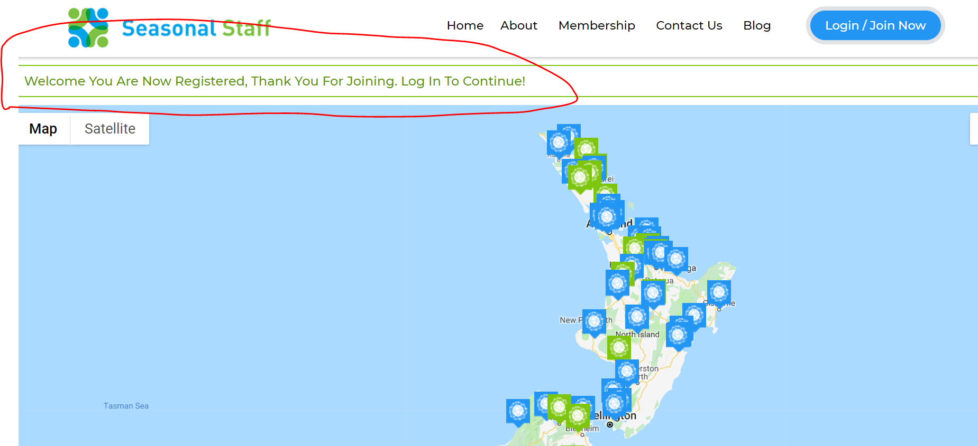

So can we have the following changes.

Can a pop up box like (the below box ) come up here, rather than the “Welcome you are now registered Thank you for joining Log in to Continue” message , as it is not getting the necessary action and people are not completing the joining process.

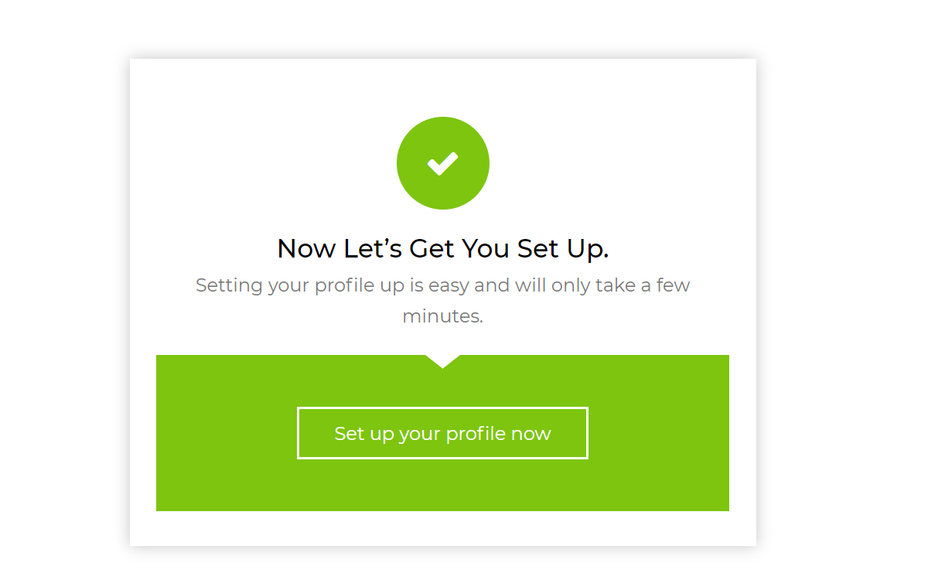

So can the wording of this pop up message be the following

Instead of “Lets get you set up” can the message say

“ Almost there”

“Login in to complete the registration process”

If where the “Set up your profile Now” button is could we put a “log in button”

This would take them to the “log in” page (see below)

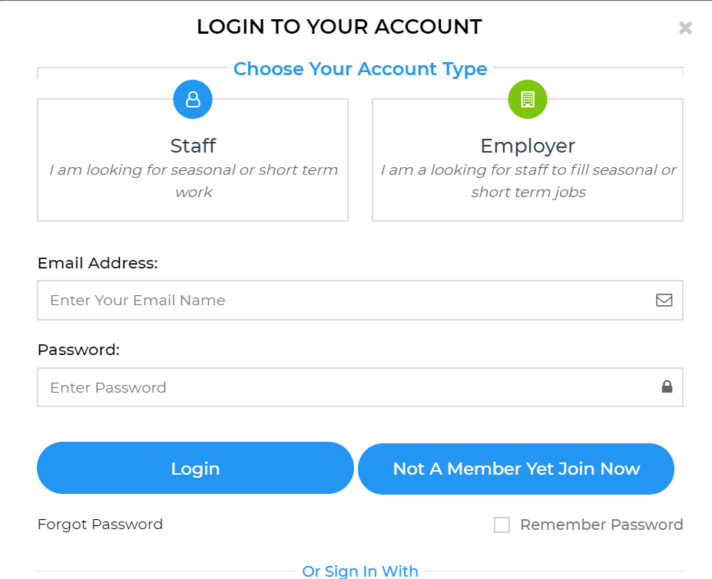

Then the process would be the same as it is now…

Eg (red pop up Verify your email box”

Thanks